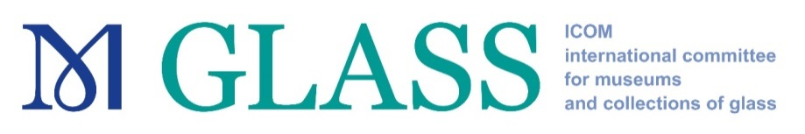

22nd Congress of AIHV & ICOM Glass Joint Meeting
fully virtual mode, 13 - 17 September 2021

GRANTS for Young Members’ attendance

GLASS IC is awarding grants for the attendance of the 22nd Congress of AIHV & ICOM Glass Joint Meeting, held in fully virtual mode from 13 to 17 September 2021 (https://eventos.fct.unl.pt/22aihv/home).
The grants are meant to cover the conference fee for young professionals, including the purchase of the Proceedings (Annales).
They are available to ICOM members who are 40 years of age or under on 31 December 2020 and are up to date with their membership dues for 2021.

Priority will be given to those applicants:

- who are individual members of GLASS IC;
- who reside in countries belonging to categories 2, 3 and 4 as defined in the ICOM membership grid (https://icom.museum/en/resources/documents/);

- who are full-time employees of a museum;
- who are under 35 years;
- who are members of ICOM and AIHV.
Young members who have received grants in the last three years (2017, 2018 and 2019) are invited to apply, however they will not be given priority for a grant in 2021.

All applications must include:
    - the completed and signed attached application form;
    - a short statement of the applicant’s motivation for attending the annual meeting and the benefits which he/she expects to derive from it;
- the applicant’s curriculum vitae indicating training, work experience, publications, as well as current work responsibilities within his/her institution (maximum one page).

The grantees will be required to attend all the activities organized by the 22nd Congress of AIHV & ICOM Glass Joint Meeting 2021 and to provide a report about the activities followed.

Applications can be made by email until 20th of June 2021 to the Secretary of the ICOM GLASS Committee, Anne-Laure Carré at anne-laure.carre@lecnam.net .
The nominees will be informed by 28th June 2021.

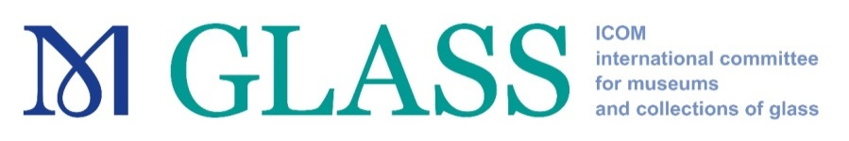

APPLICATION FORM

Applicant Details
Surname(s)
First name(s)
Date of birth
Individual ICOM Membership number
ICOM member since
Member of GLASS
since
Institution
Position in your Institution
Professional Address
City Postal code Country
Telephone number
E-mail
Additional Information
Are you an AIHV member?
Have you benefitted from ICOM Travel Grants in previous years?
If YES, please specify the type of meeting, the venue and country, as well as the year. (for example: ICOM General Conference, Rio de Janeiro, Brazil, 2013)

I herewith declare:
- that I am 40 years or younger (as of 31 December 2020) and eligible to apply according to the Criteria;

- that I am available to FULLY attend the aforementioned 22nd Congress of AIHV & ICOM Glass Joint Meeting 2021.

Date | Applicant’s Signature

This application form shall not be considered if all fields are not filled in

